Hertzsprung–Russell diagram
A plot of Luminosity (Absolute Magnitude) against the color of the stars ranging from the high-temperature blue-white stars to the low temperature red stars.

Developed in the early 1900s by Ejnar Hertzsprung and Henry Norris Russell.

This a tool used for study of evolution of Stars.

Code Explanation
1.Importing all the libraries:
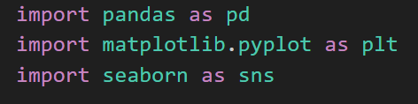
Seaborn is built on matplotlib & it gives visually better and simpler graphs.
2.Reading the data:
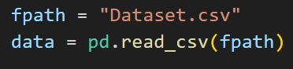
3.Renaming columns in easier names for use case:
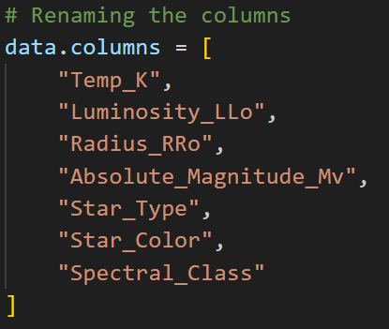

4.Converting to numeric values:
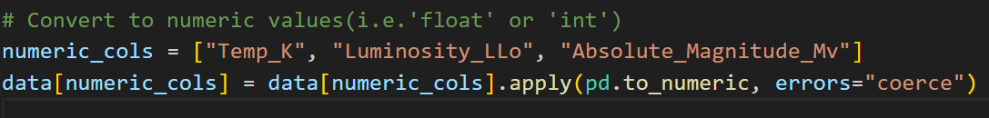

1.numeric_cols = [...]
This creates a list of the column names we want to convert to numeric (numbers).
2.data[numeric_cols]
This selects the specific columns from the DataFrame ‘data’.
gives a smaller DataFrame containing the specific columns.
3.pd.to_numeric
Try to convert all the values in this column into numbers (integers or floats).
4.errors="coerce"
Replaces any invalid data with ‘NaN’ (missing values).
5.Dropping Rows with missing values:
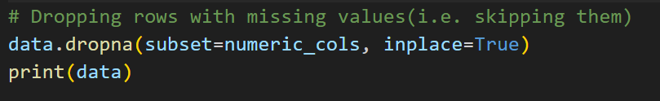

Removes/Passes the rows that have missing values so that the plot doesn’t break.
•inplace=True → modifies the original DataFrame directly (no copy).
•inplace=False (default) → returns a new DataFrame, leaving the original unchanged.

6.Plotting the Dataset values:

This plots the HR Diagram after providing all the specifications required for the graph.
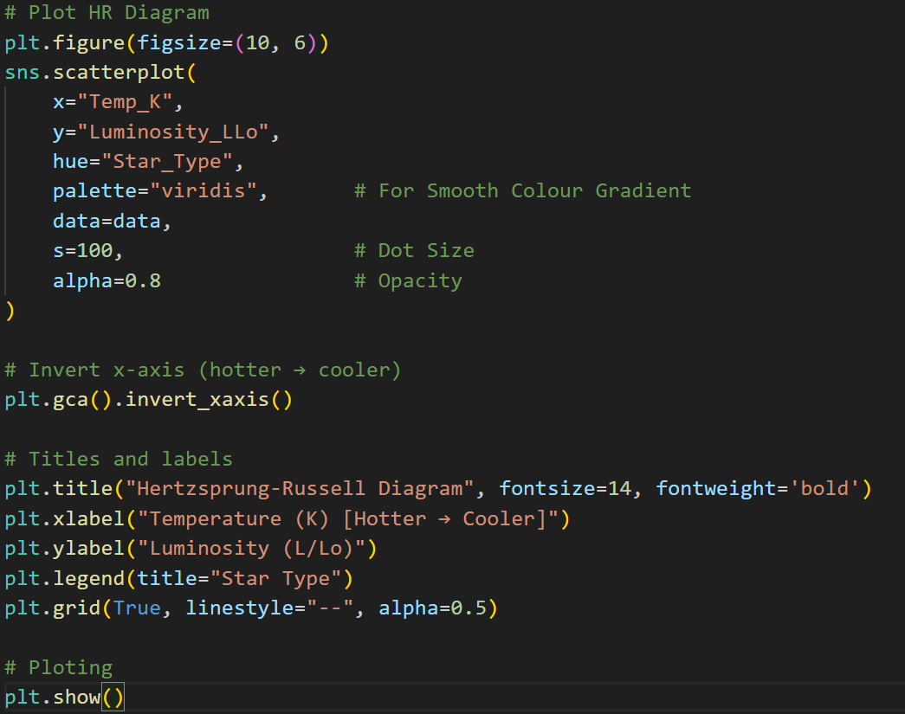

Explanation About Star Types
Star Type | Stellar Category | Description
0 | Brown Dwarf | Very cool, small, low-luminosity objects, below main sequence stars
1 | Red Dwarf | Small, cool, dim main-sequence stars (common in galaxy)
2 | White Dwarf | Hot but tiny stars (dead cores of old stars)
3 | Main Sequence | Normal, hydrogen-burning stars (like our Sun)
4 | Supergiant | Extremely bright and large stars
5 | Hypergiant | Very massive, extremely luminous stars nearing instability

Data About Some Famous Stars

Star Name | Temperature (K) | Luminosity (L/Lo) | Category (Type) | Description
Proxima Centauri | 3042 | 0.0017 | 1 – Red Dwarf | Small, cool, and faint star; closest to the Sun.
Our Sun | 5778 | 1.0 | 3 – Main Sequence | Medium-sized hydrogen-burning star; stable and yellow.
Alpha Centauri A | 5790 | 1.52 | 3 – Main Sequence | Similar to the Sun but slightly hotter and brighter.
Alpha Centauri B | 5260 | 0.50 | 3 – Main Sequence | Cooler and dimmer companion of Alpha Centauri A.

